-- Draft v.1 --
BOARD OF GOVERNORS MEETING for September, 2022
NORTHERN NEW JERSEY REGION – PORSCHE CLUB OF AMERICA, INC.

DATE: Thursday, September 8, 2022

PLACE: Online, via Zoom

PRESENT: Rich Barry, Lester Cheng, Cindy Cristello, Kim Aievoli, Janice Ernsting Doug Holcomb, Anthony Wartel Hubert King, Kevin Fitzsimmons, Bill Gilbert, Craig Mahon, Rudy Samsel, Nancy Samsel, Shannon Muller, Petra Swift, John Vogt, Peter Schneider, Knute Hancock, Dyke Henson, John Korossy, Jose DeLaCruz, Ron Miguel, Bruce Zahor

ABSENT: Grant Lenahan, Thom Calabro, Stu French, Tony Cristello

CALL TO ORDER: The meeting was called to order by President, Rich Barry, at 7:33pm.

APPROVAL of MINUTES: none.

AGENDA: [Agenda items in bold; meeting outcome in italics]

- Updates to Old Business: none
- Updates/Supplements/Redirections to written Committee Chair reports
[updates appear following each respective report]
- New Business:
  - P4US 65th Anniversary Edition – Member Bruce Zahor joined the meeting so that the BOG could express their thanks to Bruce for all he did to bring about our 1st printed P4US since the beginning of the pandemic. We’ve received many accolades from the membership. Thank you Bruce!
  - Budget Review – Lester reviewed our financials vs. the budget. This exercise will continue on a monthly basis to ensure all are properly informed and focused.
  - Cruise Night – John Vogt reviewed the plans for our re-styled Cruise Night scheduled for Saturday September 17th. Members will gather in the afternoon, enjoy the concours display, food/drink (available for purchase by the venue), live music, and Sim Racing. The Sim racing will be available at no cost to members, but donations to our charity will be accepted and encouraged. When the sun sets, a movie will be shown on the big screen “drive-in” style. John needs volunteers to assist with parking, managing the Sim racing reservation / line, charitable collections, etc. The more volunteers, the shorter the shifts!
  - Transition to Quick Books – Kim Aievoli reported that the QuickBooks transition (previously delayed) is back on track.
  - Annual Business Meeting Concerns – Janice Ernsting advises that we should identify a venue for this meeting, preferably one that can support a hybrid (Zoom) component. We will also need to consider a program component.
  - Charity Announcement – Hubert King noted that Cheshire Home is hosting their 40th Anniversary Gala on November 10th. NNJR members are welcome to attend. Please contact Hubert for additional information.

REPORTS:
- Officers' reports: [as submitted in advance; updates during/after the meeting in italics]
President: [Rich Barry] see Agenda above
Vice President: [Lester Cheng] no report
Secretary: [Cindy Cristello] no report
Treasurer: [Kim Aievoli]
The August 2022 Treasurer's Report is attached. Highlights of the report are as follows:
- The PCA Q2 region refund was received in August.
- As the DE season continues, our Watkins Glen event contributed significantly to this month's revenue. We thank Paul Miller Porsche for sponsoring our track dinner.
- Porscheforus expenses include printing of our beautiful Porscheforus Special Anniversary magazine.
Please let me know if you have any questions and/or if you would like to see the detailed transactions for your program.
Past President: [Janice Ernsting] no report

- Board and committee reports: [as submitted in advance; updates during/after the meeting in italics]
Autocross: [Grant Lenahan]
There have been no events since my report last month, in which i advised the board about the continued difficult market for autocross, mostly due to declining overall participation, increasing venue costs, reduced venue options, and more competition.
Our final event is scheduled for Sept 24th. We have, at present 37 signed up, with low sixties being a solid, but marginal event. Since autocross is traditionally a last-minute decisions/signup, this may well happen. But it is also very weather dependent - and rain bodes badly for people to stand on course for 2 ½ hours and leave their belongings next to their cars in paddock. Sigh - practice in the rain is great and relatively safe if we all use good sense.
The good news is that we have received very strong positive feedback from most of those that do attend. The issue is getting to a wider audience, often beyond PCA, to cover the significant cost and fully staff the course worker roles (about 25-30 minimum/heat)
The team (NNJR/me, RTR and CPA) are considering changes to increase our attendance. Most are two edged swords however, so require some real thinking.
We are planning to move even earlier to get dates for next year and coordinate early with Thom to see if we can avoid some of the direct competition and holiday conflicts that plagued us this year.
Business Manager: [Anthony Wartel]
4th quarter Porscheforus ad invoices will be mailed to all vendors by the end of the week.
An updated payment report will be submitted at the October BoG meeting.
Charity: [Hubert King]
Gold Ticket sales are booming. Charity thanks the sales team of Steve, Janice and Stuart.
Our next fundraising event will be at the upcoming September Cruise Night. Betsey, a Cheshire Home representative, and I will be accepting voluntary donations in coordination with the High Marquee SIM trailer. I hope BOG members have an opportunity to come over to say hi. We will also be selling Gold Tickets.
Plans are also underway for the October Wingspread Farm concours. Like last year, we will be there with Cheshire Home representatives (maybe residents if we can negotiate uneven pavement).
Plans for NNJR participation in the November Cheshire Home 40th year gala include NNJR purchasing six tickets to be raffled to members, encouraging members to donate towards the 40th year fundraising goal of $200,000, and recognition of NNJR past and continuing support at event. The event was introduced to members in the recent P4US and promotion will soon commence on social media.
Concours: [Kevin Fitzsimmons]
I have uploaded a Concours document and video for the September Porscheforus.
I've worked with Dyke on publishing/updating some of the NNJR website's Concours material including Gallery photo's, the standings are in Concours Events and Results Year To Date Scoring at this link: https://nnjr-pca.com/concours-3/#year-to-date-scoring
Working with John V on Cruise night details for the car show component.
Communicating with Paul Miller on the Sunday, Oct 9 NNJR Classic Porsche Concours Sponsored by Paul Miller Porsche
Submitted a receipt for a Concours related expense to Kim/Treasury.
Invited Cheshire Home to participate in the Wing Spread Farms Concours on October 16.

Dealer Liaison & Sponsorship: [Bill Gilbert] no report
Driver Education: [Thom Calabro]
We have 3 events left on the 2022 calendar. Our WGI 1 DE was a big success. We had 210 drivers. We are still awaiting an invoice or two from Watkins Glen, but the surplus is nearing last season's very good number.
I've already begun talks with VIR and NJMP for 2023 dates. The VIR dates will most likely be the last weekend in Oct. The NJMP Lightning dates will be similar to this year. I have asked NJMP for the weekend following our traditional Memorial Day weekend dates. If we don't get those the fall back dates are our traditional Fri/Sat Memorial Day weekend dates.
Financially PittRace, and to a lesser extent Summit Point, was very disappointing. I've been in contact with a number of PCA clubs to see if we can join forces at these venues in 2023. If we don't join another, or get weekend dates, the PittRace event should not be on our 2023 calendar.
I'm still waiting for an answer from Mid-Ohio management on a disputed charge from our May DE. They have had personnel changes, again. Once this has been satisfied, we will be able to settle the numbers with the Mid-Ohio Region PCA. I'm expecting MOR to send us their portion of the DE receipts.
DE Registrar / Club Racing: [Craig Mahon] no report
Historian: [Stu French] no report
Membership: [Rudy Samsel] / New Member: [Nancy Samsel]
August 2022 Membership Activities:
- We had a great time participating along with many new members in the "Run To The Stone Wall" Rally.
September 2022 Planned Activities:
- We plan to set up a New Member table for the upcoming Cruise Night Event on September 17.
- We tentatively plan to attend the Oktoberfest Rally on September 25.
Upcoming New Member Activities:
- Still awaiting confirmation from Raj at PMP to schedule a New Member gathering for either Saturday, November 5, or Saturday, November 12, 2022, from 9:30 am to 11:30 am.
Concours Automated Scoring Software Trial - CarShowPro.com
- Rudy was asked to be a judge at this year's New Hope Auto Show. After learning the show planned to do all of the judging and scoring using an online scoring system, Rudy could also enlist Kevin's help as a judge so that we could both try the software firsthand in the Porsche class.
- The software, CarShowPro.com, is completely web-based and is device-agnostic (i.e. no equipment to buy). There is no upfront cost and no software to download. The only constraint is that an event venue has good cell phone coverage. The cost is free for the very first show; subsequent shows would be $2.50 per car registered.
- The biggest learning from the New Hope Show (we judged approximately 25 Porsches with it at the event) was that trying to force the existing manual paper scoring system into a web-based application is inefficient.
- Rudy is working with Kevin to see whether this might be a fit to try for the upcoming Car Show and Concours events as it offers the flexibility to automate People's Choice voting.
New Member Enrollments
- June's enrollment of 16 new members was four less than planned.
- While August YTD enrollments of 165 are down from the 182 achieved YAGO (-9.2% decline YoY), we continue to track 3.1% ahead of the plan eight months into 2022.
- We remain bullish on exceeding the 2022 plan of 235 members.

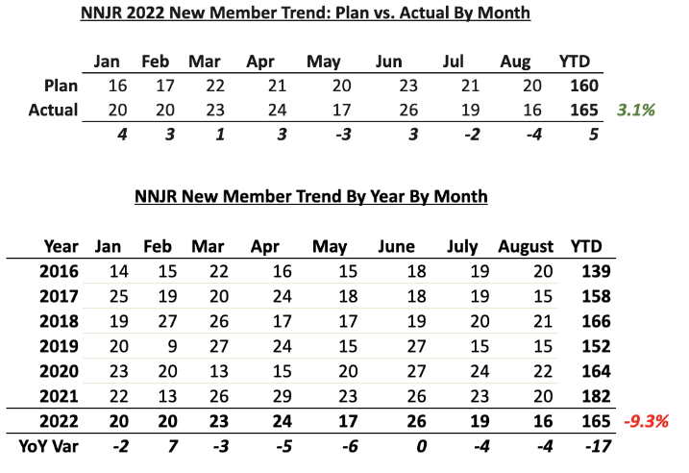

The table and bar graph below summarizes new members by month for 2016-2022 (Note: numbers highlighted in yellow are our forecasted plan for the balance of the calendar year):
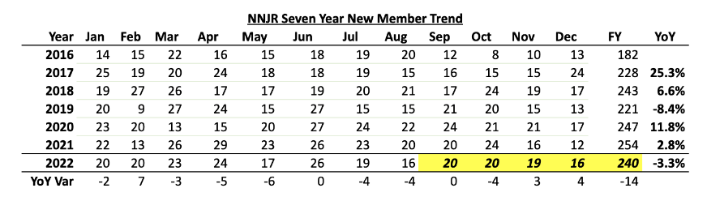

The following graph provides a visual representation of the table above:
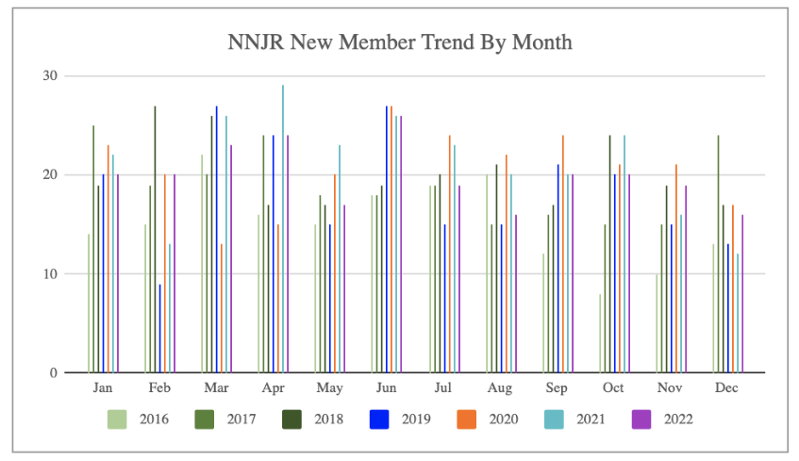

Overall Membership
Primary memberships, as of September 1, 2022, stand at 2,349. Combine that with 1,358 family (associate) members, and NNJR's total membership currently remains steady at 3,707:
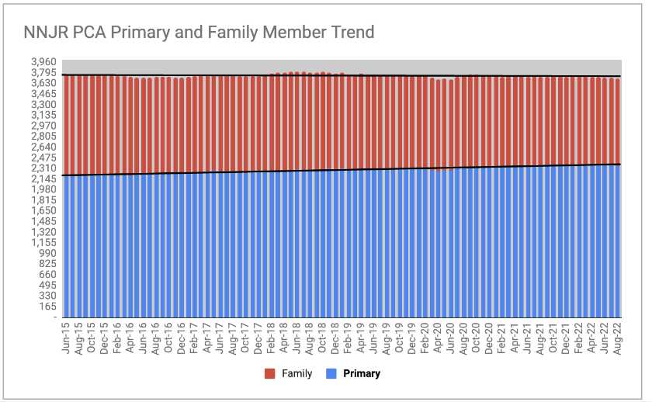
Transfers
Year-to-date, NNJR experienced only nine (12) transfers in and forty-two (42) out, for a net loss of (-30) primary members so far in 2022. Geographic moves, mostly related to retirements, continue to be the primary driver of this outflow. In the latest month, three of the five transfers out were to Florida-based chapters.
Program: [John Korossy]
Based on feedback from membership (both new and long-standing individuals), a return to in-person monthly meetings is being explored.
Suggestions & requests for more in-person activities were mentioned for informal gatherings as well as the recurring Monthly Meeting.
The contact person at the VFW Hall in Morris Plains has stated a return to their location would not likely be an option for us.
Several locations for in-person meeting options have been researched, with one site-visit (with Bill Gilbert) to the VFW Hall in Berkeley Heights. The Berkeley Heights venue would be tight on capacity (parking and meeting space) and does not provide a layout conducive to information / sidebar socialization.
One additional VFW hall was raised by Craig as an option; more details needed.
For virtual meetings - 3-4 potential speakers/topics have been nominated.
Suggest further BOG discussion on in-person vs. virtual meetings.

Publications-P4US Editor in Chief: [Petra Swift] no report
Rally/Trek: [John Vogt]
September 17: Cruise Night ,Movie Night , Sim Night.Concour, New Members/ Things are coming down the home stretch! The folks will start in to the field at 4:00 ,we could use a volunteer crew to put the Porsches in their rows. The front area will be for the concourS cars (peoples choise). The Band (Mid Life Crisis) will start aroud 4;00 to get the crowd in the mood. The Sim Racing Trailer will be up and running. We will have the Charity crew next to the trailer looking for donations. The Flicks will start at dusk. I hope the BOG and families turn out for what should be our annual event.
September 25: Oktoberfest Rally/ Our Rally crew has put together the scenic roads that NNJR has come to expect. Our annual Rally ending at our good friends The Black Forest Inn will start at High Marques with continental fare. At the restaurant we will have a traditional German feast and a drink ticket to prime us for the celebration. This is also a great time for the BOG to meet members
Social: [Tony Cristello]
Registration is open on the NNJR website for our annual wine tasting to be held Sunday October 2nd in the Paul Miller Porsche showroom. This year's theme is "les Vins de Bourgogne" in honor of Marlys and Dennis who were huge Burgundy fans. Our friends from Shop Rite Sunrise Kitchens (under the supervision of Chef Marc) will be catering. Menu selection will be finalized in the coming days.
We are excited to announce that we will return to the Highlawn Pavilion for our annual Holiday Party to be held Sunday December 4th from 3-7pm. We will announce in the next eblast and P4US, and look to open registration in mid-October.
Social Media: [Ron Miguel]
This slide deck contains more detail, but a quick summary:
The social media properties showed an improvement in growth.
Facebook
- Membership on the private Facebook group page grew from 862 to 874 members in the month
- Our members were engaged throughout the the week, except on Saturdays, perhaps because they were DRIVING.
- The public Facebook page had an increase in visitor traffic at the beginning of the month that trailed off toward the end of the month.
Instagram
- Instagram followers grew from 136 to 139 followers as of August 31.
Technical: [Knute Hancock] no report
Webmaster: [Dyke Henson]
Website Summary
- The site performed well.
- Home Page, DE and NNJR Calendar pages remain the most visited sections on the site.
- Increased activity to the registration page
- Mystery 404 error.
I would like to thank the activity chairs for providing detailed requirements for upcoming events that are using the online registration system and Doug, our very own Calendar Special Master.
Email
No issues were reported with the NNJR email system
Mystery 404 Error. You may notice a page for a 404 error (page not found) listing in the metrics. As far as I can tell it is from an external link from another property, not generated on our site, but if anyone has experienced the spaceship and elevating cow error page recently, please let me know.
Attached is a summary of metrics for the site.

MOTIONS PASSED DURING MEETING: none

UNFINISHED BUSINESS: none

ANNOUNCEMENTS: none

NEXT MEETING: Thursday, September 29, 2022

FUTURE MEETINGS: Thursday November 3, December TBD
ADJOURNMENT: Upon a motion made by Knute Hancock, and seconded by Rudy Samsel, the meeting was adjourned at 8:51pm.

Respectfully submitted,

Cindy Cristello, Secretary

