-- Draft v.1 --
BOARD OF GOVERNORS MEETING for August, 2022
NORTHERN NEW JERSEY REGION – PORSCHE CLUB OF AMERICA, INC.

DATE: Wednesday, August 3, 2022

PLACE: Online, via Zoom

PRESENT: Rich Barry, Cindy Cristello, Kim Aievoli, Janice Ernsting Doug Holcomb, Grant Lenahan, Anthony Wartel, Hubert King, Kevin Fitzsimmons, Bill Gilbert, Thom Calabro, Rudy Samsel, John Vogt, Tony Cristello, Knute Hancock, Dyke Henson, John Korossy, Jose DeLaCruz, Ron Miguel

ABSENT: Lester Cheng, Craig Mahon, Stu French, Nancy Samsel, Petra Swift, Peter Schneider

CALL TO ORDER: The meeting was called to order by President, Rich Barry, at 7:35pm.

APPROVAL of MINUTES: Knute Hancock moved to accept the previously distributed draft minutes as final. Motion was seconded by Peter Schneider and carried by majority vote.

AGENDA: [Agenda items in bold; meeting outcome in italics]

- Updates to Old Business: none
- Updates/Supplements/Redirections to written Committee Chair reports
[updates appear following each respective report]
- New Business:
- Thank You’s: (Rich Barry)
  - Picnic – The 65th picnic was highly successful – great to see so many families with children! Weather was beautiful. A big thanks to those who helped make it happen.
  - Print Magazine – Bruce Zahor has done a remarkable job assembling our print edition which is slated to be mailed out early next week. We anticipate printing plenty of extra copies for our sponsors.
- Nominating Committee – (Janice Ernsting) The Nominating Committee has completed their work and names of the nominees were published in P4US as required under our bylaws. She shared some of the learnings from going through the process:
    - We should be cognizant of changes to the average age of our membership and our growth rate. She notes that we seen many folks moving south.
    - Folks are very interested in a printed publication.
    - Folks enjoy informal “meet-ups” as a convenient, low-key way of connecting.
    - It is very hard to attract volunteers to assist at events.
    - BOG members should act as ambassadors at club events and try to identify members seeking to increase their involvement.
    - Sim Racing and CCC events are very attractive to younger members – this can be an opportunity to draw the younger demographic in.
- Budget Update – Starting with next month’s meeting, Lester will lead monthly budget updates due to the budget volatility.
- Charity Update – (Hubert King). Our three largest Charity fundraisers are (i) Welcome to the Club, (ii) Gold ticket raffle, and (iii) our Fall Fundraiser; which pre-pandemic was a Tricky-tray auction event. Given that Cheshire Home is hosting a large fundraising event this Fall, there is concern that attempting to host a similar event with overlapping invitees in the same timeframe will result in decreased participation in one or possibly both events. Hubert will be exploring other date/format options to increase potential attendance and maximize our impact. Additional details in the Charity report below.
- Advertising Options – (Rudy Samsel) Discussion on NNJR’s policy that one must be a P4US advertiser in order to host or be a sponsor of events, the pros/cons of digital-based ads (with hyperlinks), and if/how our intention to produce a printed magazine (twice per year) may have an impact.
- Website needs: process update – Dyke Hensen provided guidance around information that activity chairs should provide when setting up online registration for events. Please include:
    - When registration should open / close, and (if applicable) maximum attendees
    - Description of the event including date, time, venue
    - Any additional info to be collected at time of registration
    - Registration fees / Cancellation policy
    - Relevant Links – venue website, map
    - Whether off-line registration is permitted
REPORTS:
- Officers' reports: [as submitted in advance; updates during/after the meeting in italics]
President: [Rich Barry] see Agenda above
Vice President: [Lester Cheng] no report
Secretary: [Cindy Cristello] Minutes from the May 2022 meeting have been posted to the website.
Treasurer: [Kim Aievoli]
The June 2022 Treasurer's Report is attached. Highlights of the report are as follows:
    - PCA National sent NNJR the Q1 region refund which is shown in Membership income
    - The club's 65th anniversary celebration picnic was a spectacular event and we received a generous amount of sponsor income.
    - The DE, AutoX and Rally seasons are underway with associated income and expenses
    - The NNJR van's EZPass has been renewed.
The July 2022 Treasurer's Report is attached. Highlights of the report are as follows:
    - The Porscheforus continues to bring in revenue from our club's advertisers.
    - Our AutoX and Drivers Ed programs are mid way through the season generating income and incurring expenses.
    - NNJR's 65th picnic brings in some remaining revenue.
Please let me know if you have any questions and/or if you would like to see the detailed transactions for your program.
Past President: [Janice Ernsting] no report

- Board and committee reports: [as submitted in advance; updates during/after the meeting in italics]
Autocross: [Grant Lenahan] no report
Business Manager: [Anthony Wartel]
3rd quarter payments for Porscheforus ads continue to come in.
(1) vendor is past due for a one year lump sum payment.
(1) vendor is past due for their 2nd quarter payment.
A detailed report of payments will be submitted at the September BoG meeting.
Jack Daniel's Porsche in Bergen County has voiced interest in becoming more involved in our region with a possibility of advertising in Porscheforus.
Advertising rate information has been sent to two other vendors introduced to us by other members of the Board of Governors. To date we have had no response from either lead.

Charity: [Hubert King]
Planning for our Fall Fundraiser has started. One event that we will be part of is the major-fundraising 40-year gala by Cheshire Home. Sales of 10-person tables at $250 per plate along with opportunities for direct contributions to Cheshire Home through advertising or sponsorship of attendance are available. As co-chair of event, I will promote NNJR member participation, including attendance and contributions.
Because of the timing conflict with this event, the NNJR plans for Charity Event must be changed. Survey questions about the rescheduled event were recently sent to the BOG. Among the considerations are timing (December or January?), format (Auction, Casino Night?) and family-friendly vs adult night out. The record-setting charity contributions of the past two years shows that NNJR members are willing to open their wallets. A family-friendly afternoon event in January seems very appealing and a great way to promote inclusion of our younger (perhaps 4 door owner) members.
Concours: [Kevin Fitzsimmons]
I have a draft document for the September Porscheforus that I'll upload to Petra this weekend.
Paul Miller Classic postponed , working with Jennifer on an alternative date (proposed Sunday, October 9th as a good fit for the NNJR calendar)
Working with John regarding a Car Show component for the Sept 17: Cruise & Drive-in Movie Night.
Hagerty Youth Judge kits received.
Dealer Liaison & Sponsorship: [Bill Gilbert] no report
Driver Education: [Thom Calabro]
We are halfway through the DE season. The on-track driving has been very good. I can only recall one relatively minor car/wall incident so far this season. The bottom line is another matter. The hits to the budget are not good. We seem to be down on attendance at every event. The worst to date was PittRace. We went from 2 last year to 3 days this, at the request of last year's attendees. Our attendance this year was down by 30%. I had long conversations with the GM and also the owner of PittRace. The GM indicated that all the groups renting their facility are suffering from lower attendance. He also stated that some of the for profit groups may not make it, which could free up a weekend for us. I let him know that if we didn't get a weekend, or could not partner with another group, that this could be our last year at PittRace.
Our partnership with the Mid-Ohio Region PCA continued this year. Last year we had an instructed event, we ended up moderately in the black. This year we had an Advanced Only DE, along with Club Racing. We finished moderately in the red. Next year's event we hope to join MOR again, but go back to the instructed DE.
The two events at NJMP - Lightning 1 was even, T'bolt slightly negative. The Lime Rock numbers have yet to come in.
I've started conversations with MOR and NER regarding partnering at some events next season.
DE Registrar / Club Racing: [Craig Mahon] no report
Historian: [Stu French] no report
Membership: [Rudy Samsel] / New Member: [Nancy Samsel]
July 2022 Membership Activities:
    - With the postponed Porsche Classic Car Show slated for July 24, we're awaiting confirmation of a new date to inform new members.
    - Eliminated the original September 17 New Member Gathering at PMP to accommodate Concours / Drive-in now planned for that date. We plan to have a table for New Members at this event.
August 2022 Planned Activities:
    - We plan to attend Sunday's "Run To The Stone Wall" Rally and have sent out special reminder invitations to all newbies enrolled in the past year.
    - Rudy will be a judge at the New Hope Auto Show on August 13 and 14 in the Porsche class on Sunday, August 14, which is limited to cars built up to the model year 1997 (yes, that's a change from years prior). Anyone interested in helping?
Upcoming New Member Activities:
    - Awaiting confirmation from Raj at PMP to schedule a New Member gathering for either Saturday, November 5, or Saturday, November 12, 2022, from 9:30 am to 11:30 am.
New Member Enrollments
    - June's enrollment of 19 new members was two less than planned.
    - While June YTD enrollments of 149 are down from the 162 achieved YAGO (-8.0% decline YoY), we continue to track 6.4% ahead of the plan seven months into 2022.
    - We remain bullish for now on increasing our 2022 New Member forecast to 245 versus the plan of 235.
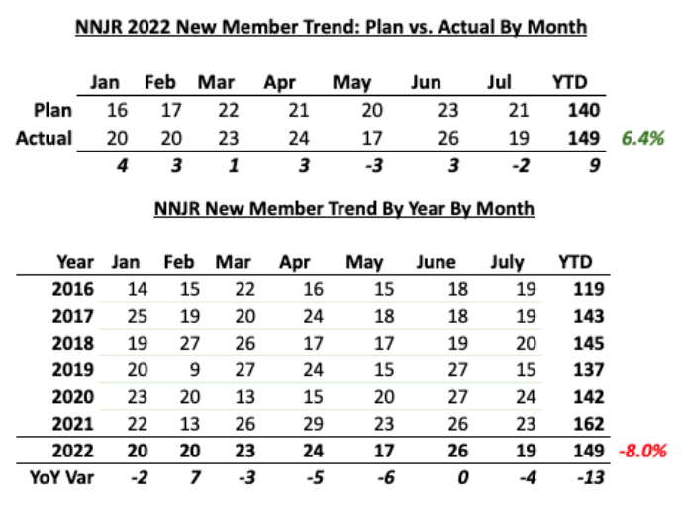
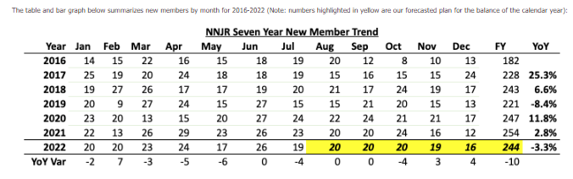
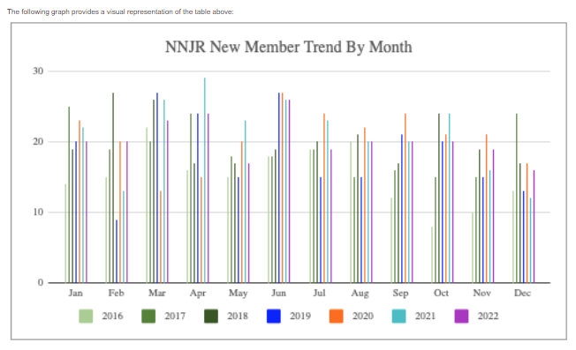
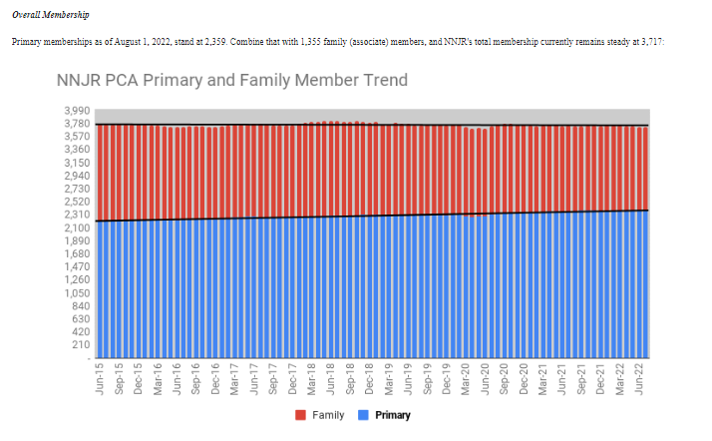
Nominating Committee [Janice Ernsting]
The Nominating Committee for NNJR's 2023 slate of officers has completed the candidate interviews. The committee report has been posted on the NNJR website and forwarded to the Editor for publication in the September and October issues of Porscheforus. Unless someone steps up to run against one of our candidates, our job is complete. I would like to thank those who served on the committee; Anthony Wartel, Ron Miguel, Britt Findlay and Glen Ochten. Your time and commitment is greatly appreciated.
Program: [John Korossy]
    - Transition from Shannon is complete - thank you for your hard work and efforts managing the NNJR program activities!
    - July meeting will be omitted as the new program lead completes the organization and review of potential speaker / topics under consideration
    - Ideas and suggestions for future topics, speakers, and/or activities are welcomed
    - Several potential speakers and topics identified while networking during the recent Porsche Parade
Publications-P4US Editor in Chief: [Petra Swift] no report
Rally/Trek: [John Vogt]
The Run For The Stone Walls Rally will be Sunday the 7th.The team has put together great roads (as Usual) along with good gags to keep all on their toes. The ending feast will be at the Glen Gardener Inn, a fabulous spot with great ambience and history. I hope many of the BOG attend.
Social: [Tony Cristello]
The 65th Anniversary Celebration Summer event was an overwhelming success, attended by over 300 people. We thank our sponsors for their generosity, and all the members who volunteered to help things run smoothly.
Social Media [Ron Miguel]
[July] The social media properties showed a slight slowing in growth.
Facebook
      - Membership on the private Facebook group page grew from 840 to 856 members in the month
      - Our members were most active on Mondays and Sundays, with less activity all other days.
      - The public Facebook page saw a significantly slower pace of visitors
Instagram
      - Instagram followers grew from 131 to 135 followers as of June 30.
[August] This slide deck contains more detail, but a quick summary: The social media properties showed a continued slowing in growth.
Facebook
      - Membership on the private Facebook group page grew from 856 to 862 members in the month
      - Our members were most active on Thursdays, with less activity all other days.
      - The public Facebook page saw a continued slower pace of visitors
Instagram
      - Instagram followers grew from 135 to 136 followers as of July 31.
Technical: [Knute Hancock] no report
Webmaster: [Dyke Henson]
Website Summary:
      - The site performed well.
      - Overall site traffic was down 17%
      - Home Page, DE and NNJR Calendar pages remain the most visited sections on the site.
      - Results are in for the National Web contents...we didn't win.
The best thing about entering the Website contest is you get to see other sites and contact the site managers and exchange ideas. I have attached both the winners and the scores and comments from the judges on our site. You can judge the judges yourself.
I do plan to do a homepage refresh towards the end of the rear as on content creating has picked up and we can start to use a "current activity" magazine style template instead of our current "static" home page design now.
Things to think about if you plan to need the website for your events, posts, popups or online sales:
Your next event or activity
Activity chairs need to start thinking like consumer members when creating content for members on the website, either as events, popups, or an online event or product registration. If you plan to have registration on the website, all the details need to be provided early and in detail. If you are expecting updates to registration counts, and payment summaries, I need to know that before we create the offer, after the fact creates reporting nightmares. Remember, I post and advise, but I do not create your content. If you ask me to "just write something" you will travel that road at your own risk.
Tentative Events
If you "reserved" a tentative date for an event way back in March it should be "taken" or removed BY NOW
Online Registration
Website traffic analysis shows members are now using the "event registration" menu from the home page of from event on either are Google or Website calendar.
If you plan an "on-site" registration at the event location the calendar needs to have that information explicitly communicated. Now that we have a menu for event registration, that information also has to be consistent.
If you plan to use the onsite registration system, you need to ask yourself all the questions that may come up beforehand from a member.
      - Is there a rain date?
      - Will we offer refunds?
      - Can I pay cash "at the door?
      - What if I want extra T-Shirts?
      - Can I bring my dog, cat, or Boa Constrictor?
      - (ONLY if she stays wrapped around my neck)
Product Sales
If you have a product like a Grill Badge, T-shirts, etc?
      - Is it taxable?
      - Is there an inventory control requirement
      - Is shipping included or separate?
      - Is it returnable?
      - Can we take back orders?
Email
No issues were reported with the NNJR email system.

MOTIONS PASSED DURING MEETING: none

UNFINISHED BUSINESS: none

ANNOUNCEMENTS: none

NEXT MEETING: Thursday, September 8, 2022

FUTURE MEETINGS: Thursday September 29, Thursday November 3, December TBD
ADJOURNMENT: Upon a motion made by Knute Hancock, and seconded by Anthony Wartel, the meeting was adjourned at 9:08 pm.

Respectfully submitted,

Cindy Cristello, Secretary

